Name: Hafiz M. Muneeb Akbar
Roll No: SU92-BSAIM-F24-048
Subject: Programming for Artificial Intelligence (LAB)

Lab Task 1
House Price Prediction
Function & Method Reference Document

Project Overview
This notebook implements a machine learning pipeline to predict house sale prices using the Ames Housing Dataset. It uses a Random Forest Regressor trained on 33 numeric features extracted from 1,460 training records. The code is organized into the following sections: library imports, data loading, data exploration, missing value handling, model training, evaluation, and submission generation.

1. Importing Libraries
The notebook imports several Python libraries, each serving a specific role:

Library Import Functions & Settings
import pandas as pd | Imports the pandas library for data manipulation. Used to load CSVs, filter columns, and build DataFrames.
import numpy as np | Imports NumPy for numerical operations like computing the median of arrays.
import matplotlib.pyplot as plt | Imports Matplotlib for creating charts such as histograms and scatter plots.
import seaborn as sns | Imports Seaborn (a higher-level plotting library built on Matplotlib) — imported but available for enhanced visualizations.
from sklearn.model_selection import train_test_split | Imports a utility to split data into training and validation sets.
from sklearn.ensemble import RandomForestRegressor | Imports the Random Forest algorithm used to train the prediction model.
from sklearn.metrics import mean_absolute_error | Imports a metric to measure how far off predictions are from actual prices.
pd.set_option('display.max_columns', None) | Configures pandas to show all columns when printing a DataFrame (no column truncation).

2. Data Loading
Two CSV files are loaded into pandas DataFrames:

Data Loading Functions
pd.read_csv('train.csv') | Reads the training dataset from a CSV file and stores it in a DataFrame. Training data has 1,460 rows and 81 columns (including the target SalePrice).
pd.read_csv('test.csv') | Reads the test dataset (1,459 rows, 80 columns — no SalePrice column). Used later to generate predictions.
train_data.shape | Returns a tuple (rows, columns) describing the size of the DataFrame. Used here to confirm the data loaded correctly.

3. Data Exploration
These functions help understand the structure and statistics of the dataset:

Data Exploration Functions
train_data.head() | Displays the first 5 rows of the DataFrame. Used to visually inspect the data and confirm it loaded correctly.
train_data.info() | Prints a summary of each column: its name, number of non-null values, and data type (int64, float64, or object). Helps identify which columns have missing data.
train_data.describe() | Computes summary statistics for all numeric columns: count, mean, standard deviation, min, max, and quartiles (25%, 50%, 75%).
train_data['SalePrice'].mean() | Calculates the arithmetic mean (average) of the SalePrice column.
train_data['SalePrice'].median() | Calculates the median (middle value) of the SalePrice column.
train_data['SalePrice'].min() | Returns the smallest value in the SalePrice column.
train_data['SalePrice'].max() | Returns the largest value in the SalePrice column.

3.1 Visualizing SalePrice Distribution
Plotting Functions (Distribution)
plt.figure(figsize=(10, 6)) | Creates a new figure with a width of 10 inches and a height of 6 inches.
plt.hist(..., bins=50, edgecolor='black') | Draws a histogram with 50 bins. Each bar shows how many houses fall within a price range. Black edges make bars visually distinct.
plt.xlabel() / plt.ylabel() | Labels the x-axis (Sale Price) and y-axis (Frequency) of the histogram.
plt.title() | Sets the chart title: 'Distribution of House Sale Prices'.
plt.ticklabel_format(style='plain', axis='x') | Disables scientific notation on the x-axis so prices display as full numbers (e.g., 200000 instead of 2e5).
plt.show() | Renders and displays the chart.

4. Handling Missing Values
Before training, the code identifies and removes columns with missing values to keep things simple:

Missing Value Detection Functions
train_data.isnull().sum() | Returns a Series where each value is the count of missing (NaN) values in that column. Reveals which columns need attention.
missing_values[missing_values > 0] | Filters only the columns that have at least one missing value.
.sort_values(ascending=False) | Sorts the columns from most to fewest missing values, making it easy to see which columns have the most gaps.
train_data.select_dtypes(include=['int64', 'float64']) | Selects only numeric columns (integers and floats) from the DataFrame. Excludes text-based (object) columns.
.columns.tolist() | Converts the column index to a regular Python list of column names.
[col for col in numeric_cols if ...] | A list comprehension — a compact Python loop that builds a new list. Used here to filter out 'Id' and 'SalePrice', and later to keep only columns with no missing values.
train_data[col].isnull().sum() == 0 | Returns True if a column has zero missing values. Used to keep only complete numeric features.

5. Preparing Training Data
The features (X) and target (y) are separated, then split into training and validation sets:

Data Preparation Functions
X = train_data[features_no_missing] | Creates the feature matrix X by selecting only the 33 complete numeric columns from the training data.
y = train_data['SalePrice'] | Creates the target vector y containing the actual sale prices.
X.shape / y.shape | Confirms the dimensions: X is (1460, 33) and y is (1460,).
train_test_split(X, y, train_size=0.8, test_size=0.2, random_state=42) | Splits X and y into training (80%) and validation (20%) sets. random_state=42 ensures reproducible results — the same split every time. Returns X_train, X_valid, y_train, y_valid.

6. Training the Model
A Random Forest Regressor is created and trained on the training data:

Model Training Functions
RandomForestRegressor(...) | Creates a Random Forest model — an ensemble of many decision trees. Parameters: n_estimators=100 (100 trees), random_state=42 (reproducible), max_depth=10 (limits tree depth to prevent overfitting), min_samples_split=5 (a node must have at least 5 samples to split further).
model.fit(X_train, y_train) | Trains the model by learning patterns from the training features (X_train) and their corresponding prices (y_train).
model.predict(X_valid) | Generates price predictions for the validation set. Returns a NumPy array of predicted prices.
mean_absolute_error(y_valid, predictions_valid) | Computes the Mean Absolute Error (MAE) — the average dollar amount by which predictions differ from actual prices. A lower MAE indicates a better model. Result: ~$18,312.

6.1 Visualizing Predictions vs Actual
Scatter Plot Functions
plt.scatter(y_valid, predictions_valid, alpha=0.5) | Creates a scatter plot comparing actual prices (x-axis) to predicted prices (y-axis). alpha=0.5 makes points semi-transparent to show density.
plt.plot([y_valid.min(), y_valid.max()], [...], 'r--', lw=2) | Draws a red dashed diagonal line representing perfect predictions. Points close to this line are accurate predictions.

7. Feature Importance
After training, the model can report which features contributed most to its predictions:

Feature Importance Functions
model.feature_importances_ | A property of the trained Random Forest that returns an array of importance scores — one per feature. Scores sum to 1.0.
pd.DataFrame({'feature': ..., 'importance': ...}) | Creates a new DataFrame with two columns: feature names and their importance scores.
.sort_values('importance', ascending=False) | Sorts the DataFrame so the most important features appear first.
.head(10) | Displays only the top 10 rows — the 10 most important features.

Top Features Identified:
- OverallQual (57.5%) — Overall material and finish quality of the house
- GrLivArea (12.9%) — Above-grade living area in square feet
- TotalBsmtSF (3.8%) — Total basement square footage
- 2ndFlrSF (3.8%) — Second floor square footage
- BsmtFinSF1 (3.4%) — Type 1 finished basement area

8. Final Model Training
The model is retrained on the complete training dataset (all 1,460 rows, not just 80%) to maximize accuracy before making predictions on the test set:

Final Model Functions
final_model = RandomForestRegressor(...) | Creates a new Random Forest model with identical parameters to the evaluation model.
final_model.fit(X, y) | Trains on the full dataset (X and y instead of X_train and y_train), giving the model more data to learn from before making test predictions.

9. Generating Test Predictions
The trained final model is applied to the unseen test data:

Test Prediction Functions
X_test = test_data[features_no_missing] | Selects the same 33 features from the test dataset. Consistency with training features is essential.
X_test.isnull().sum().sum() | Checks for missing values in the test features. The double .sum() first sums per column, then across columns. Result: 10 missing values (handled by the Random Forest algorithm internally).
final_model.predict(X_test) | Generates a price prediction for each of the 1,459 test houses.
np.median(test_predictions) | Computes the median of the prediction array using NumPy.

10. Creating the Submission File
A CSV submission file is created in the format required for competition evaluation:

Submission File Functions
pd.DataFrame({'Id': test_data['Id'], 'SalePrice': test_predictions}) | Creates a new DataFrame with two columns: Id (the house identifier from the test set) and SalePrice (the model's predicted price).
.head(10) | Previews the first 10 rows of the submission to verify it looks correct.
submission.shape | Confirms the submission has 1,459 rows and 2 columns.
submission.to_csv('submission.csv', index=False) | Saves the DataFrame to a CSV file. index=False prevents pandas from writing the row numbers as an extra column.

Quick Reference Summary

Category | Key Function | What It Does
Data Loading | pd.read_csv() | Loads CSV file into a DataFrame
Exploration | .head() / .info() / .describe() | Previews and summarizes dataset
Missing Values | .isnull().sum() | Counts missing values per column
Feature Selection | select_dtypes() + list comprehension | Picks complete numeric columns
Train/Test Split | train_test_split() | Divides data 80% train / 20% validation
Model Training | RandomForestRegressor + .fit() | Trains 100-tree ensemble model
Evaluation | mean_absolute_error() | Measures average prediction error (~$18K)
Feature Importance | model.feature_importances_ | Shows which features drive predictions
Prediction | model.predict() | Generates price estimates for new data
Submission | DataFrame.to_csv() | Saves predictions to CSV file

Output Screenshot

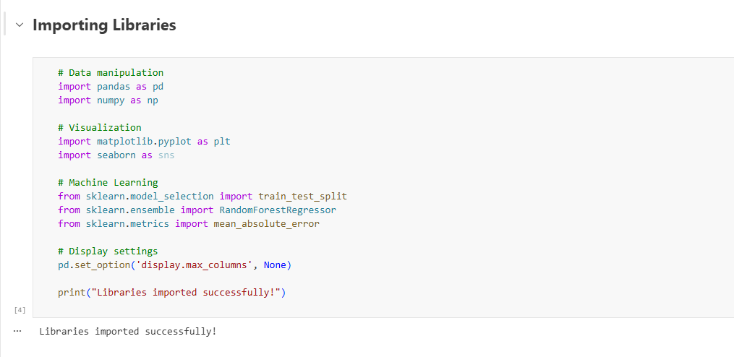
Figure 1: Importing The Libraries

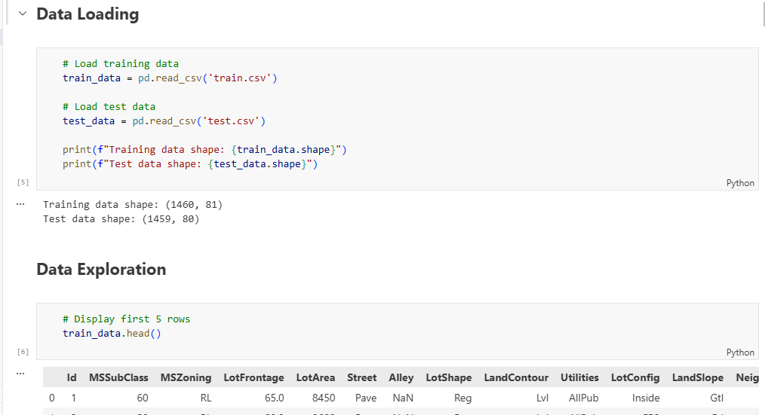
Figure 2: Data Loading and Explorations steps

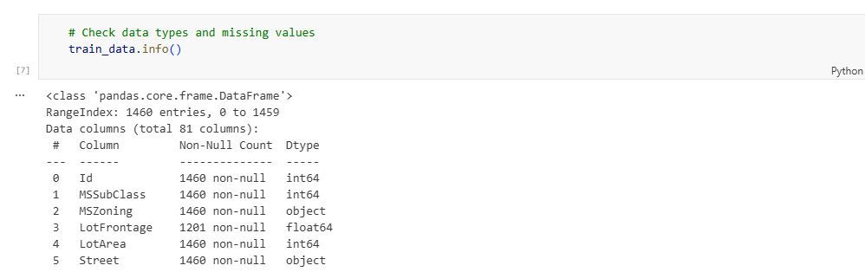

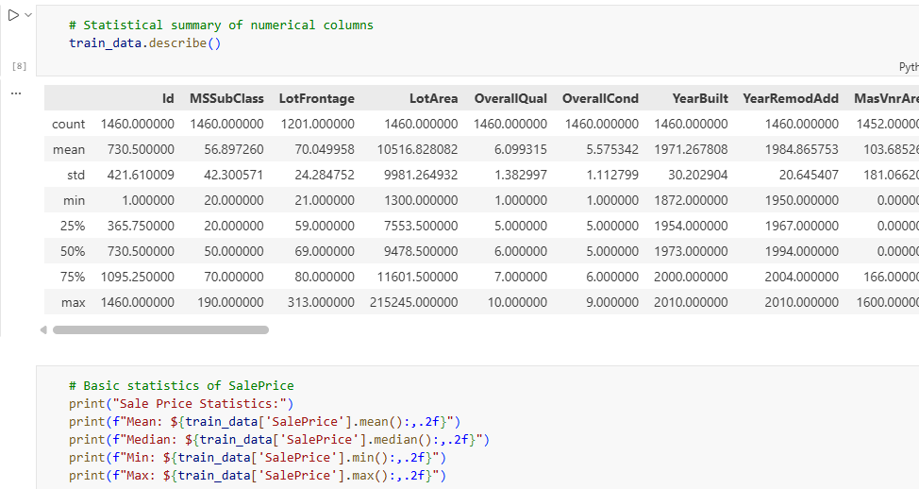

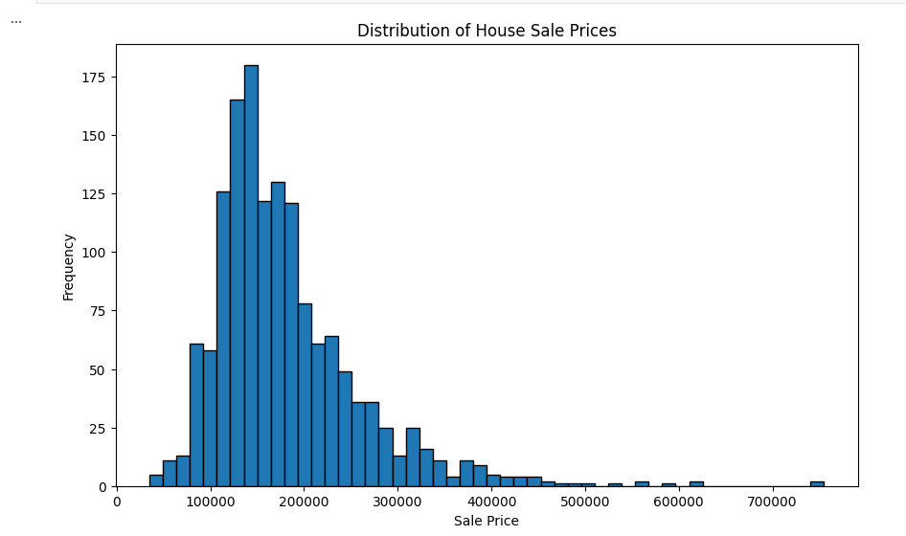
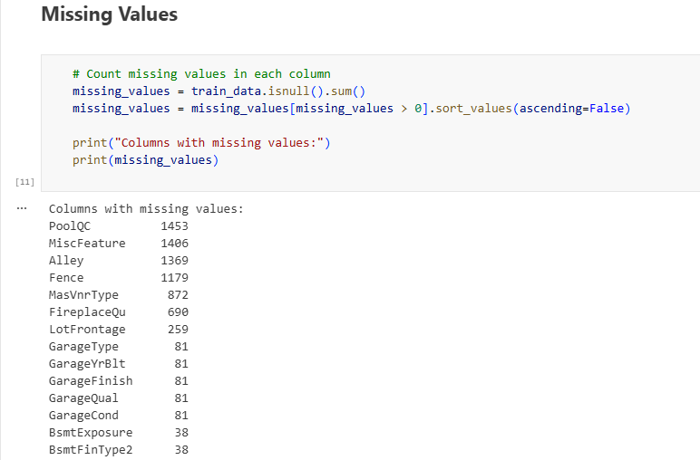
Figure 3: Missing Values
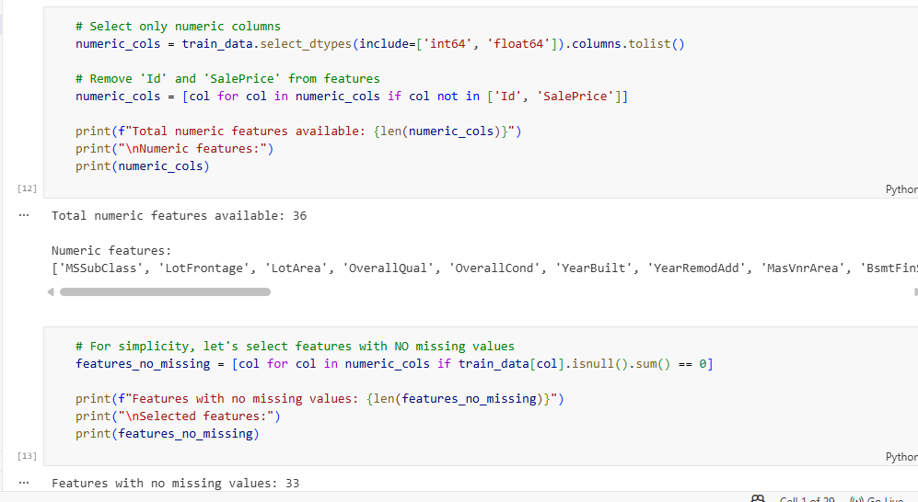
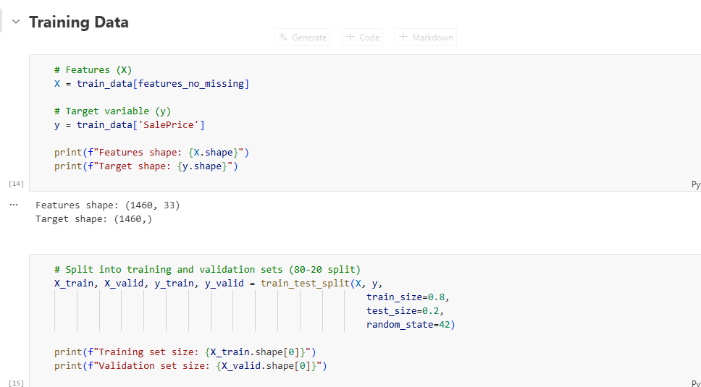
Figure 4: Training and Testing
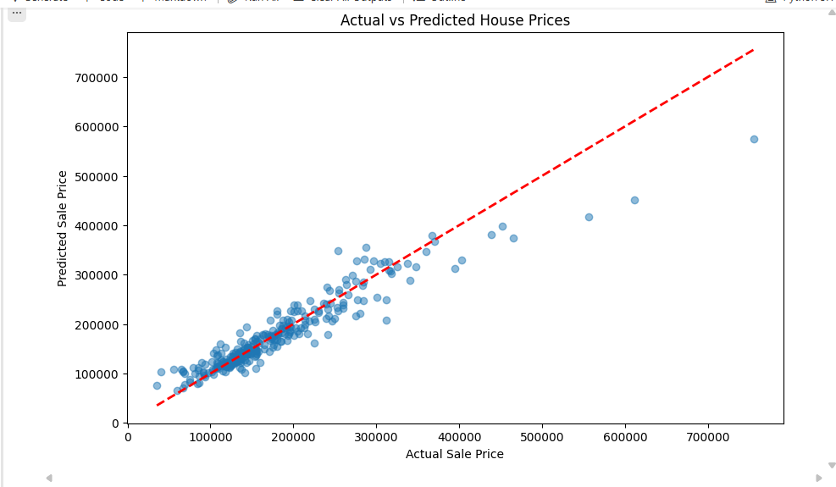
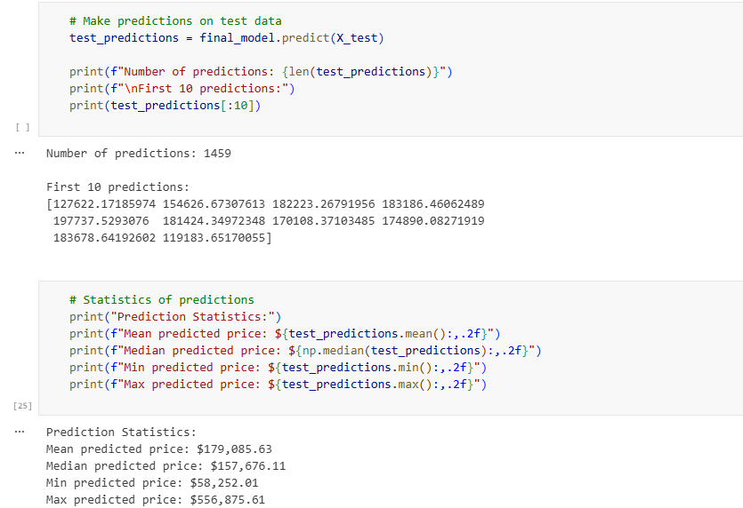

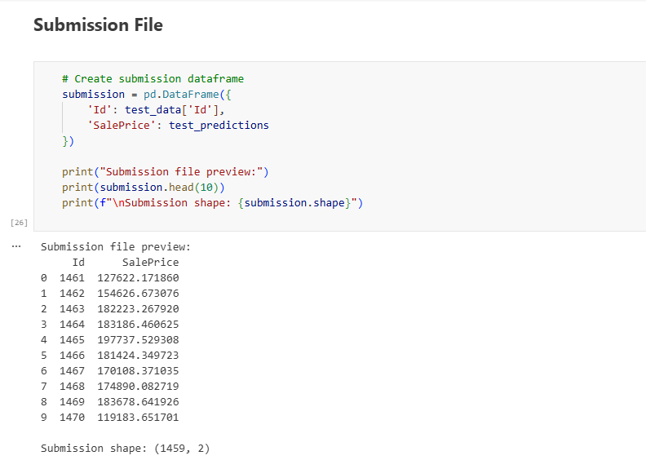
Figure 5: Final Submission File

